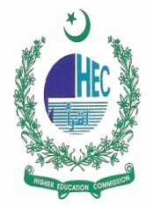
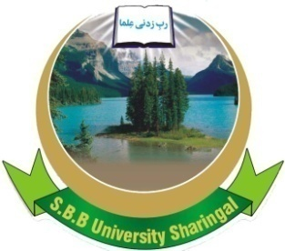
SHAHEED BB UNIVERSITY,
SHERINGAL, DIR UPPER

INVITATION FOR BIDS

- Shaheed Benazir Bhutto University Sheringal, Dir Upper (The Employer) invites sealed bids from the eligible firms or persons duly licensed by the Pakistan Engineering Council (PEC) in C-6 or above category for the “Construction of Tube Well” under the Developmental Project, titled “Development of University of Dir, Sheringal”. Estimated cost is Rs. 2.788 million which shall be completed within three months.
- A complete set of Bidding Documents may be downloaded from the Shaheed Benazir Bhutto University Sheringal, official Website, by the interested eligible Bidders free of cost.
- All bids must be accompanied by a Bid Security in the amount, equal to 2% of the total bid cost in the shape of deposit at call or Bank guarantee in favor Employer and must be delivered to the Office of Accounts Officer, Project Management Unit, on or before 06 /09/2022 (1100 hours) and shall be opened at 11:30 hours of the same day in the presence of the Bidders or their representatives who choose to attend, at the committee Room of Guest House, SBB University Sheringal, Dir Upper.

Project Director
Development of University of Dir, Sheringal
0944-885402/0300-0527798

